**Project Development in Full Stack Development**

**Definition**

Zentra Chatbot is a full-stack web application that allows users to interact with website content through a conversational interface. It uses AI technology to scrape, process, and vectorize website content, enabling users to ask questions about any website and receive relevant information through a chat interface.

**Scope**

The project encompasses a complete end-to-end solution with:

* A React-based frontend with Material UI components providing an intuitive chat interface
* A Node.js backend for user authentication, chat history management, and website data storage
* A Python backend implementing AI/ML capabilities for website content processing and natural language understanding
* Integration with vector databases for efficient information retrieval
* Document upload and processing capabilities

**Objective**

The primary objective of Zentra Chatbot is to make website information more accessible through natural language conversations. Users can:

1. Process any website URL to extract and analyze its content
2. Upload documents in various formats to be processed
3. Ask questions about the website/document content in natural language
4. Access their chat history and previously processed websites
5. Manage conversations effectively through a user-friendly interface

**Features**

**Core Functionality**

1. **Website Content Processing**
   * URL input and validation
   * Website scraping and content extraction
   * Progress tracking during website processing
   * Storage of processed website data for future use
2. **Document Processing**
   * Support for multiple file formats (.pdf, .docx, .txt, .md, .csv, .json)
   * Document preview functionality
   * Conversion of document content for AI processing
3. **Conversational Interface**
   * Real-time chat with processed websites/documents
   * Support for complex queries about website content
   * Markdown rendering for formatted responses
   * Code syntax highlighting in responses
4. **User Account Management**
   * User registration and authentication
   * Secure login with JWT tokens
   * User session management
   * User-specific data storage

**Additional Features**

1. **Chat Management**
   * Creating new chats
   * Viewing chat history
   * Renaming conversations
   * Deleting conversations
2. **Website Management**
   * Storing previously processed websites
   * Quick loading of previously processed websites
   * Removing websites from history
3. **UI/UX Elements**
   * Responsive layout with sidebar navigation
   * Dark theme interface
   * Typing indicators
   * Progress tracking for long operations
   * Error handling and notifications
   * Animated components

**Technical Architecture**

1. **Frontend**: React.js with Material UI, state management through React contexts
2. **Backend**: Node.js Express server with MongoDB integration
3. **AI Backend**: Python Flask server with natural language processing capabilities
4. **Database**: MongoDB for user data and chat history, vector database for content embeddings
5. **Authentication**: JWT-based authentication system
6. **Integration**: RESTful API communication between components

**Screenshots**

1. **Login/Registration Screen**
   * Clean interface for user authentication
   * Form fields for email/password input
   * Registration option for new users

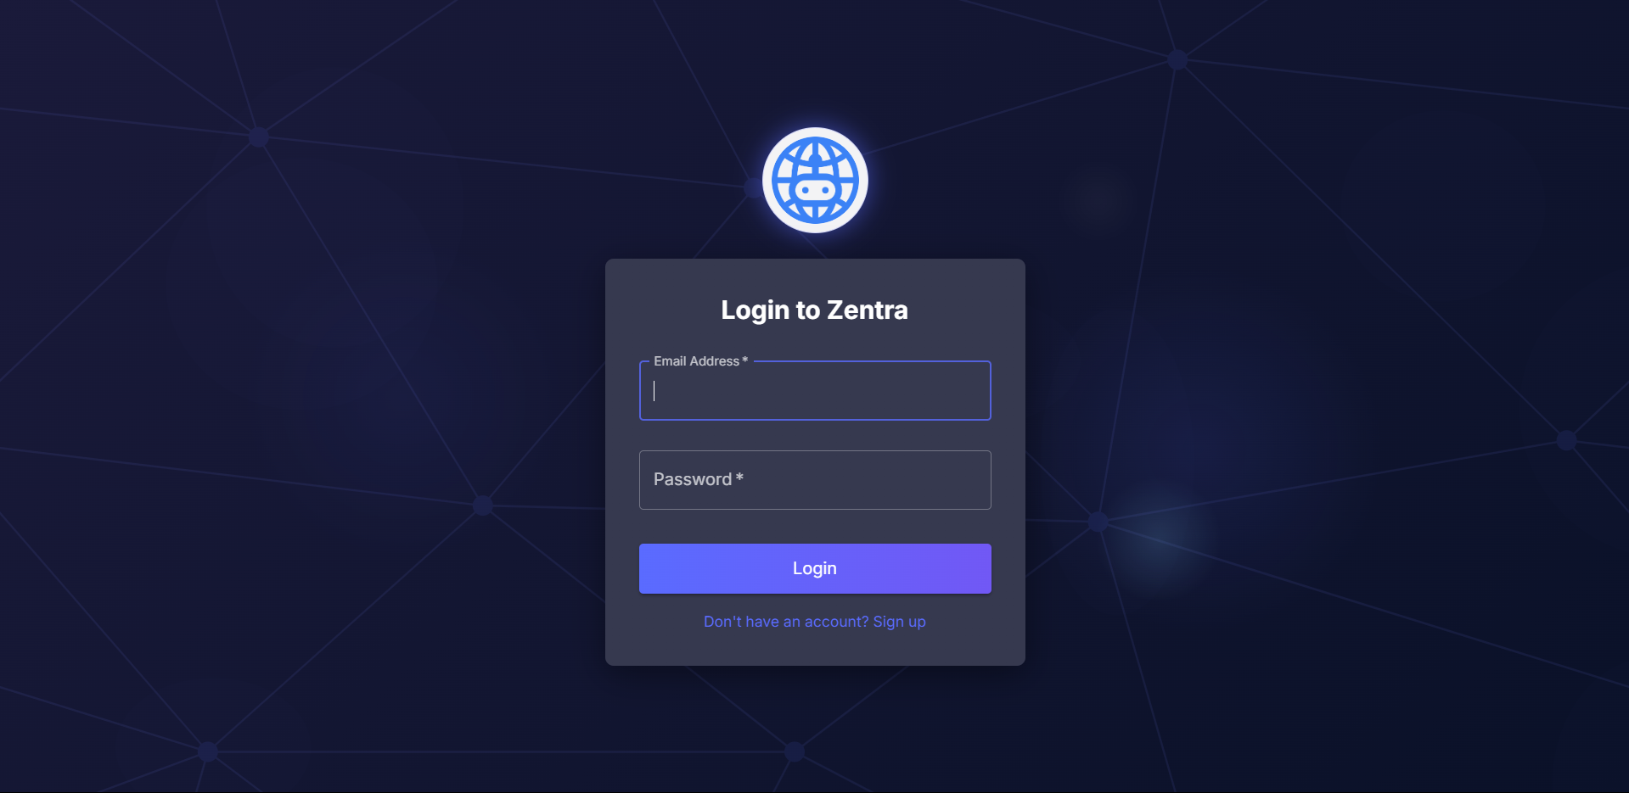

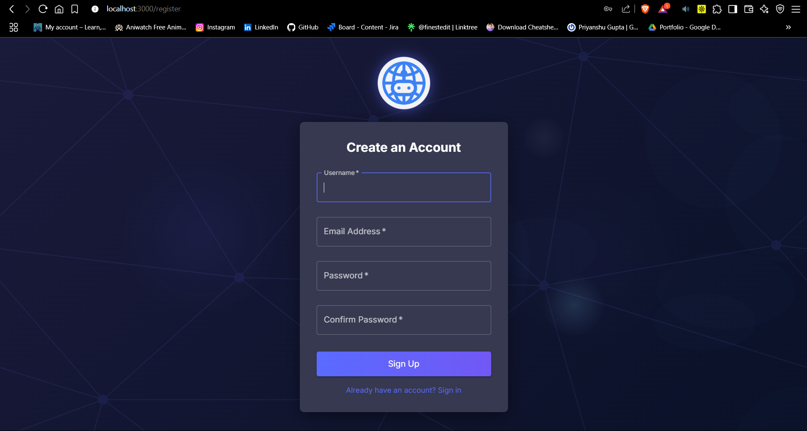

1. **Main Chat Interface**
   * Three-panel layout with:
     + Left sidebar for chat history and navigation
     + Central chat area with message bubbles
     + Right sidebar for website loading and document upload
   * Dark theme with professional color scheme
   * Bot avatar and typing indicators

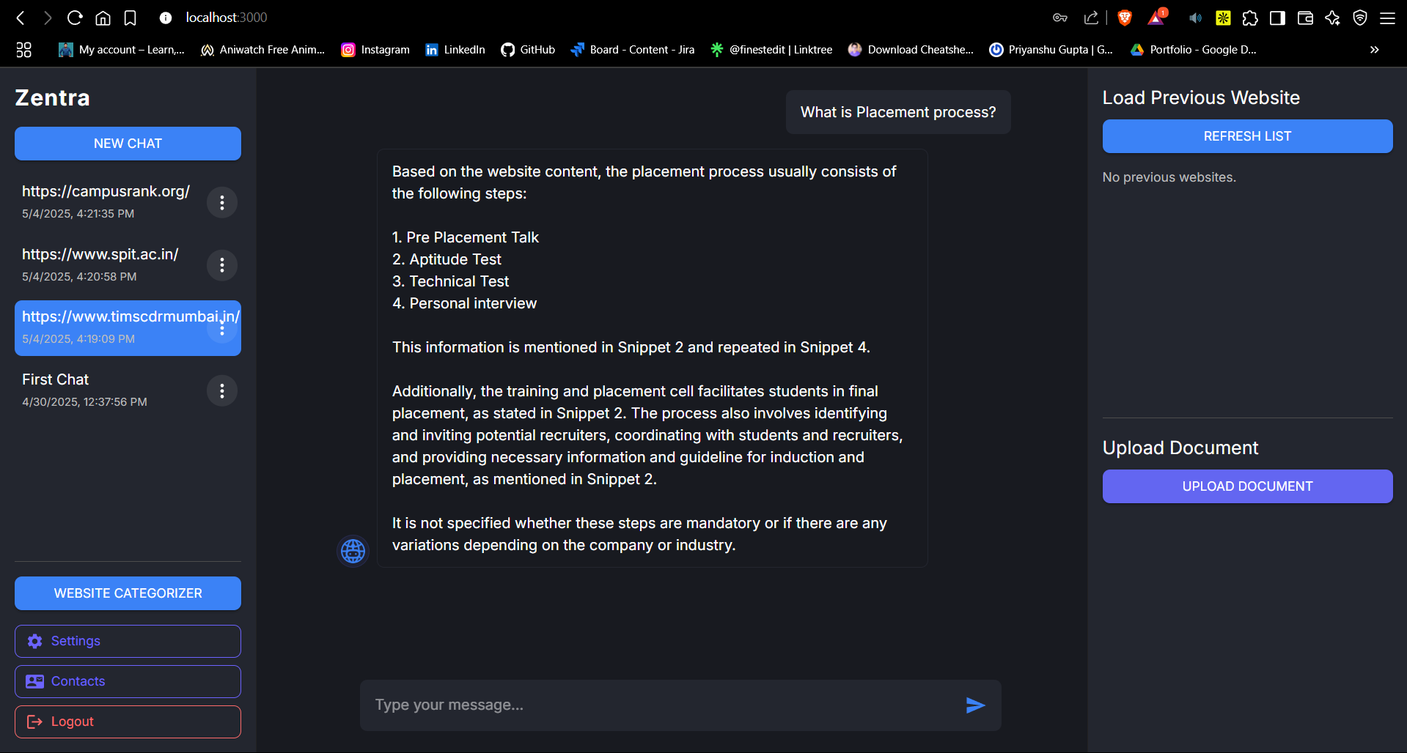

1. **Website Processing**
   * URL input interface
   * Processing status indicators
   * Website content preview

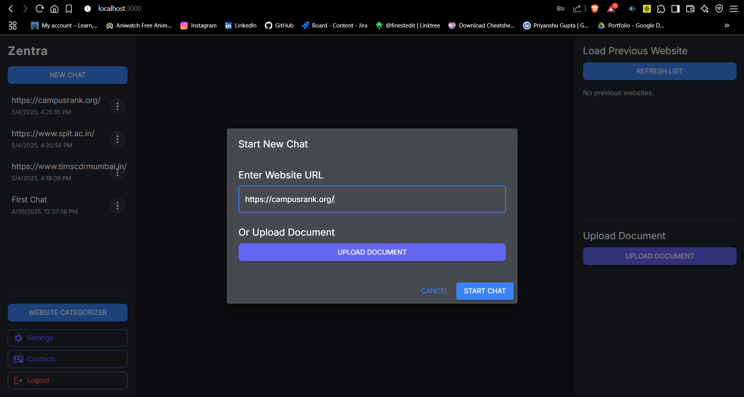

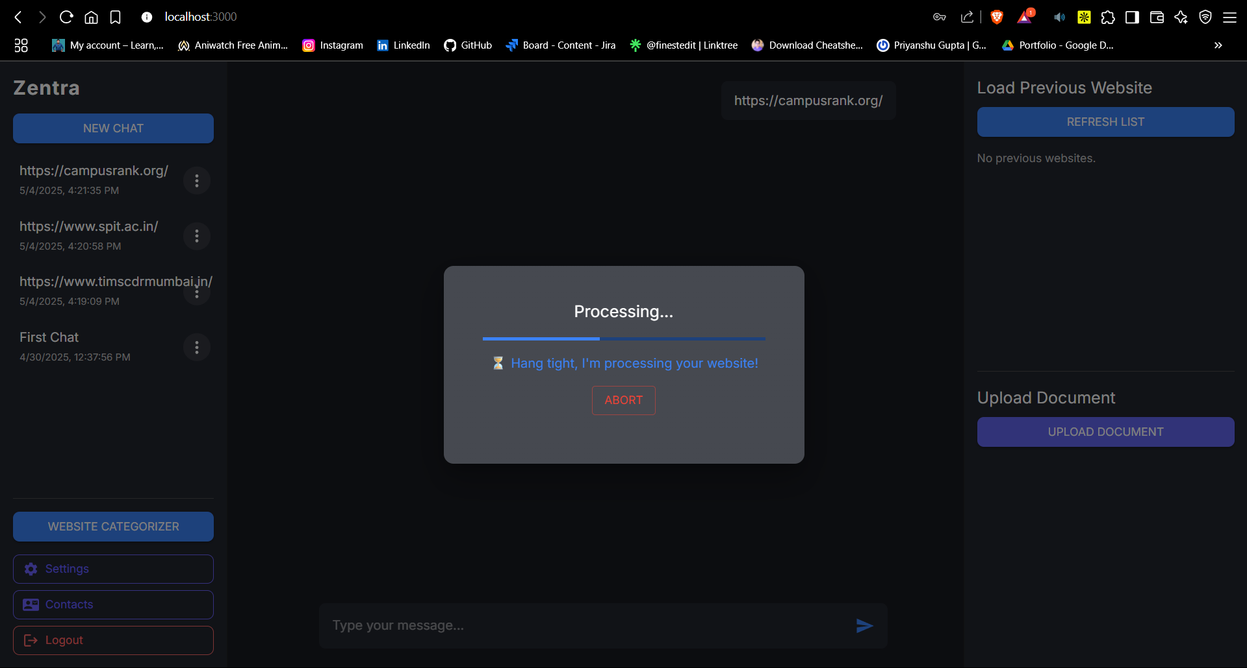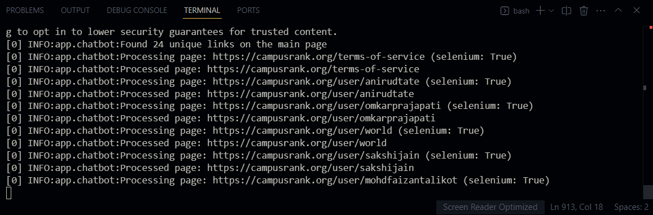

1. **Document Upload**
   * File selector interface
   * Supported file format indicators
   * Document preview modal

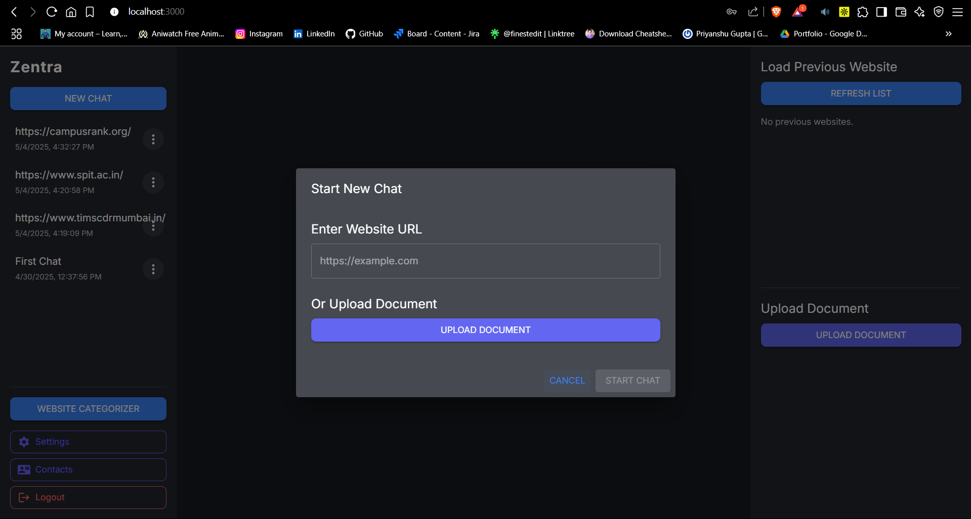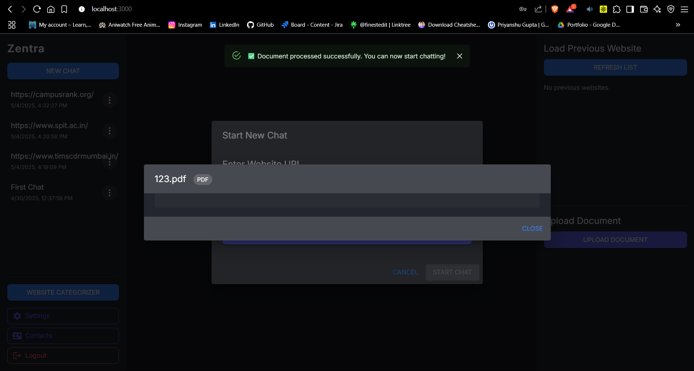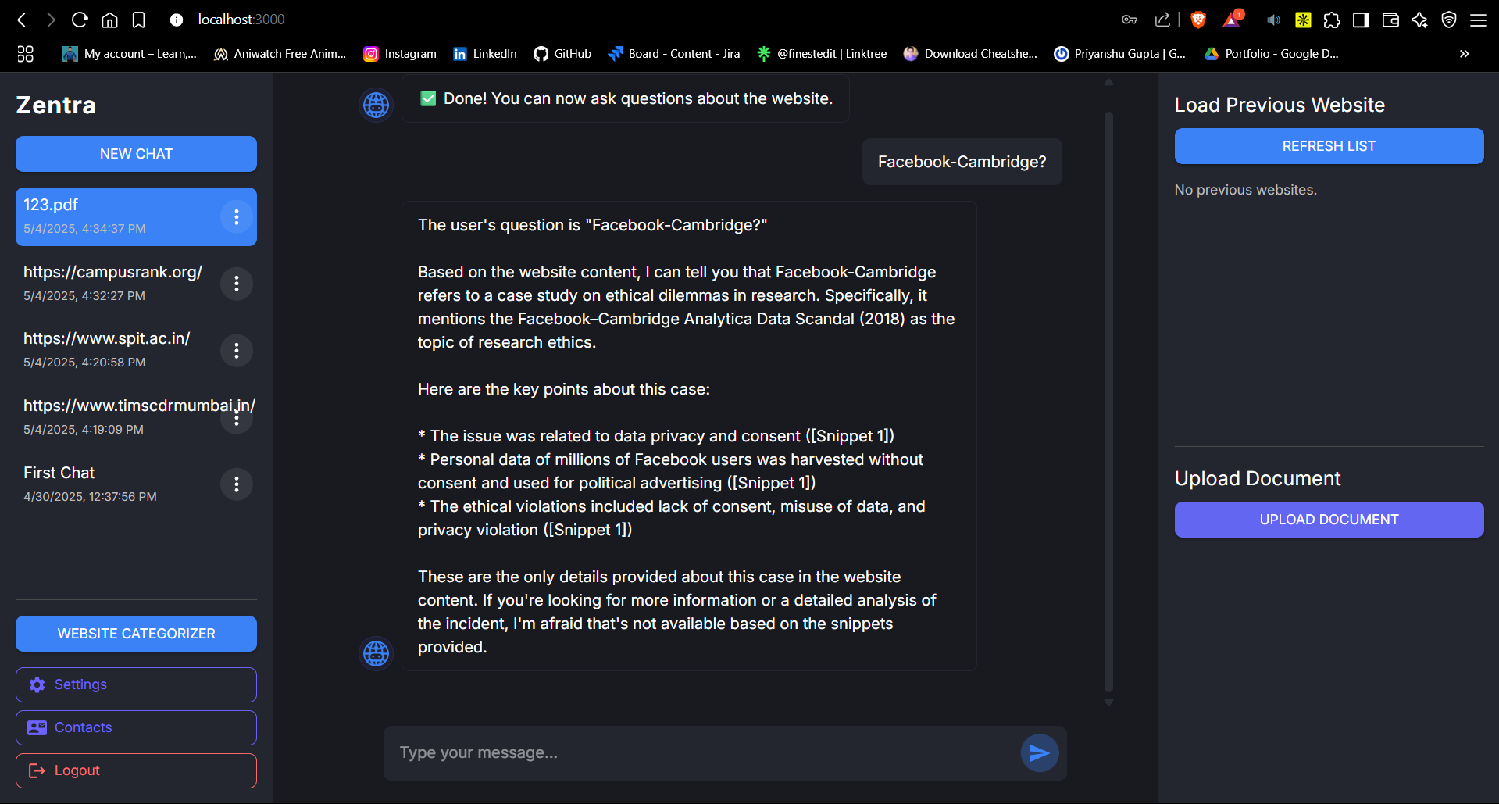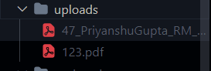

1. **Chat History**
   * List of previous conversations
   * Website/document thumbnails
   * Date/time indicators
   * Context menu for chat management

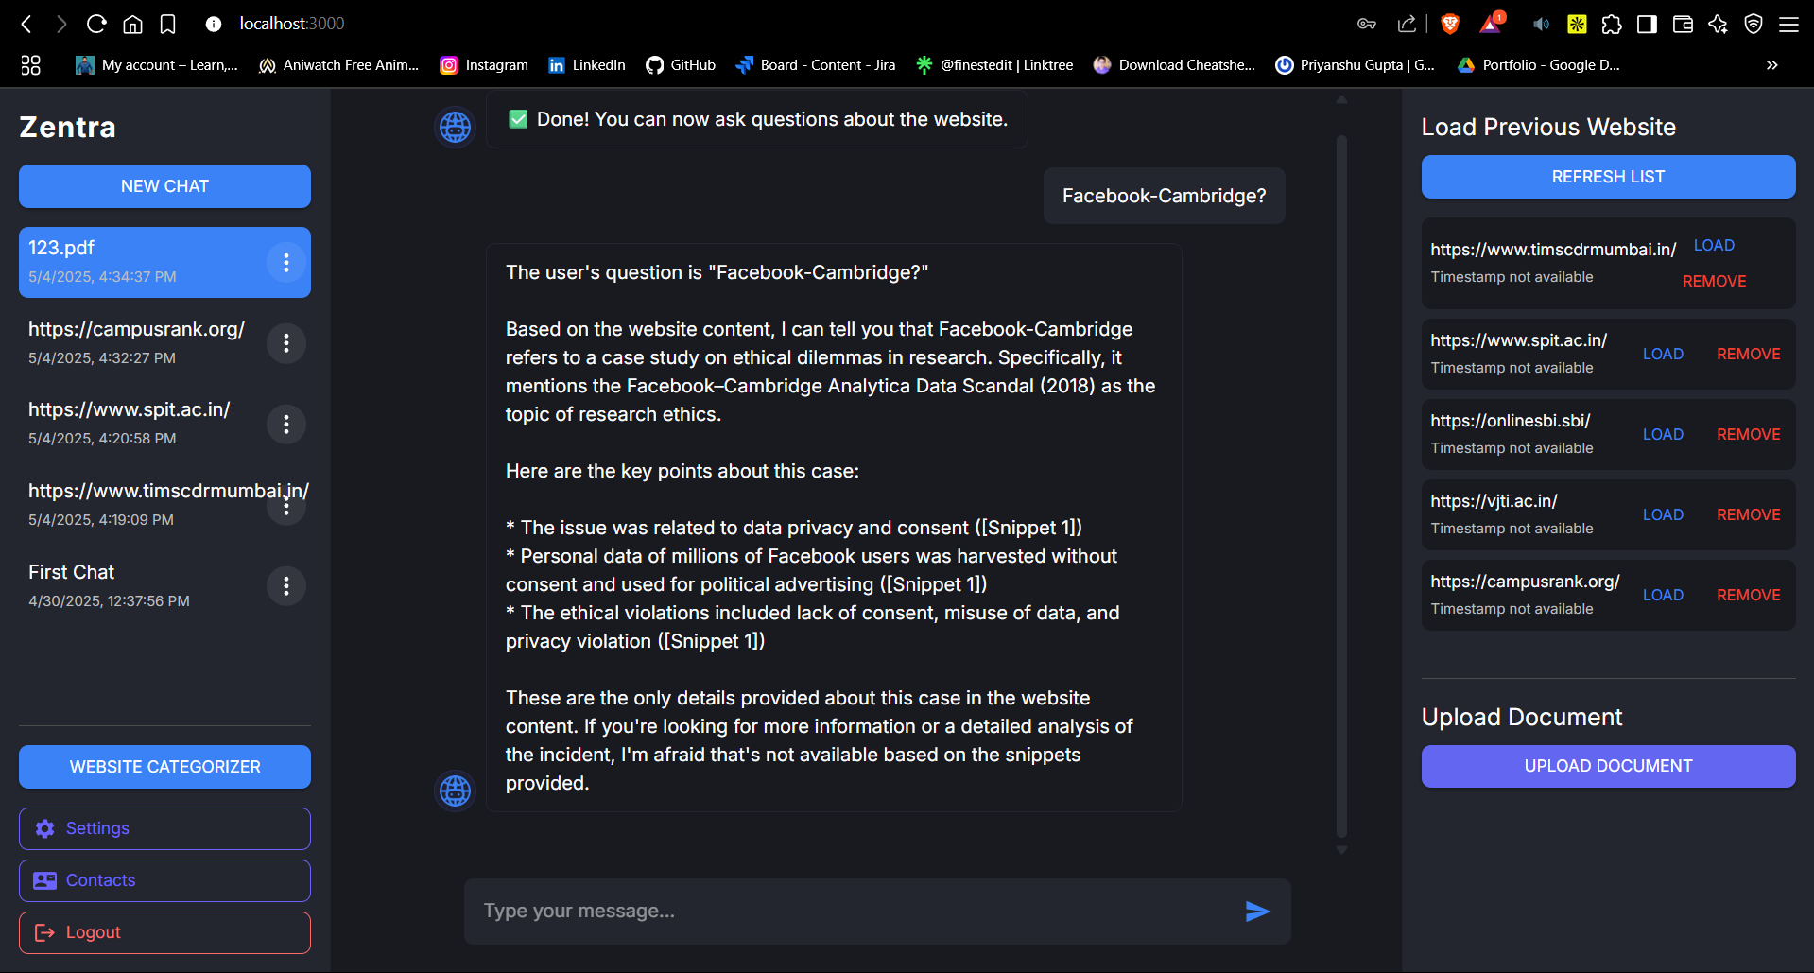

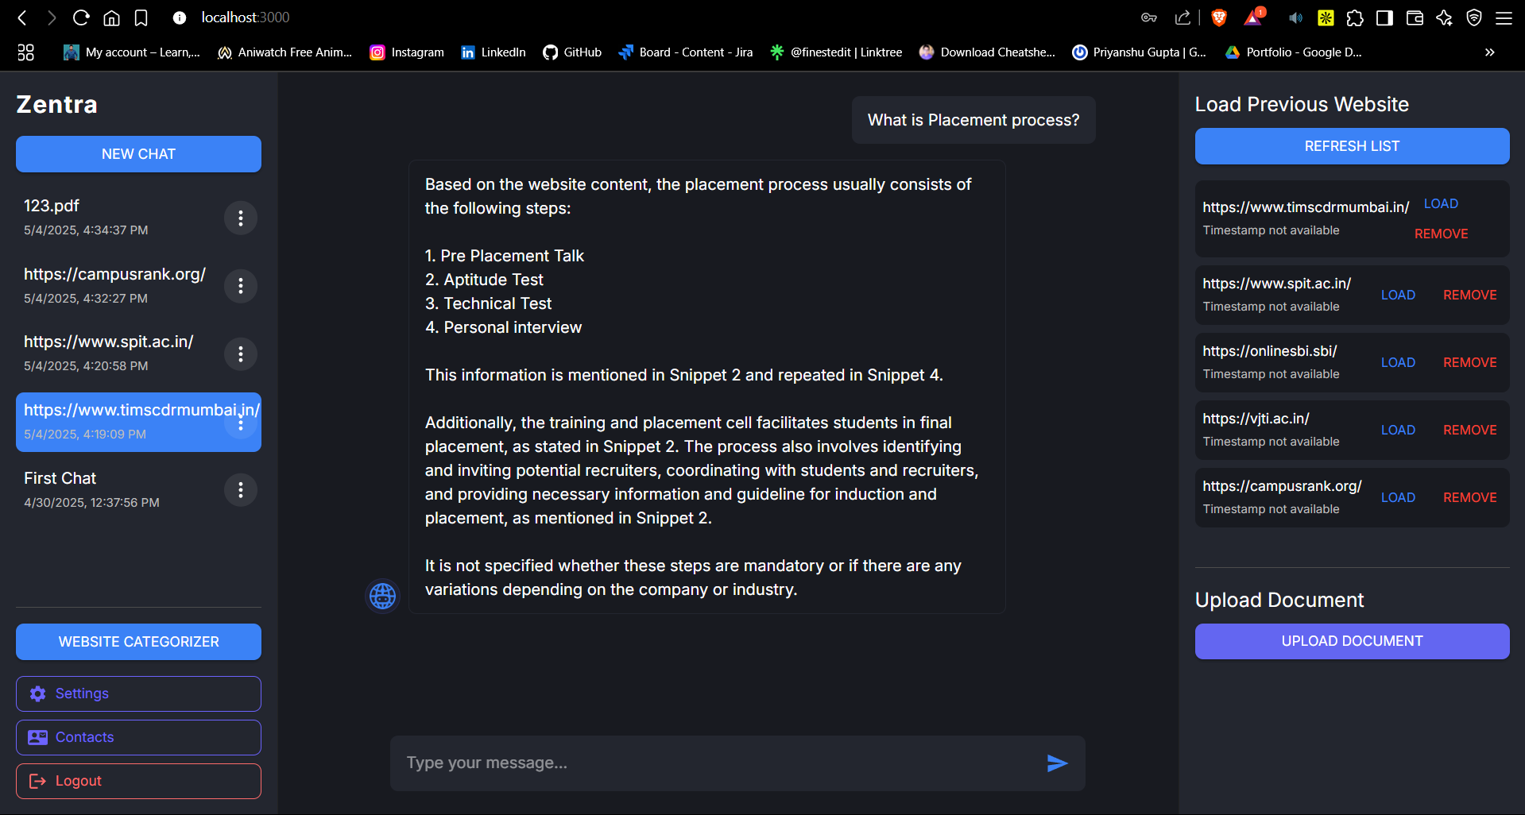

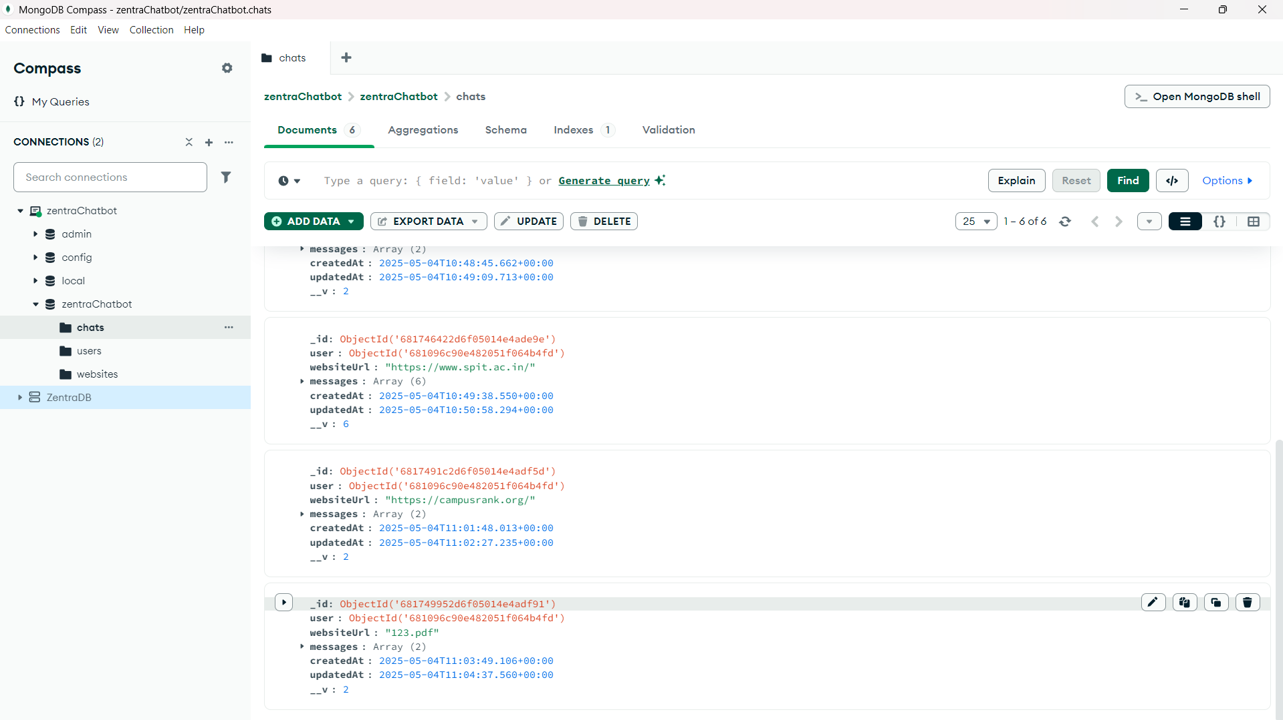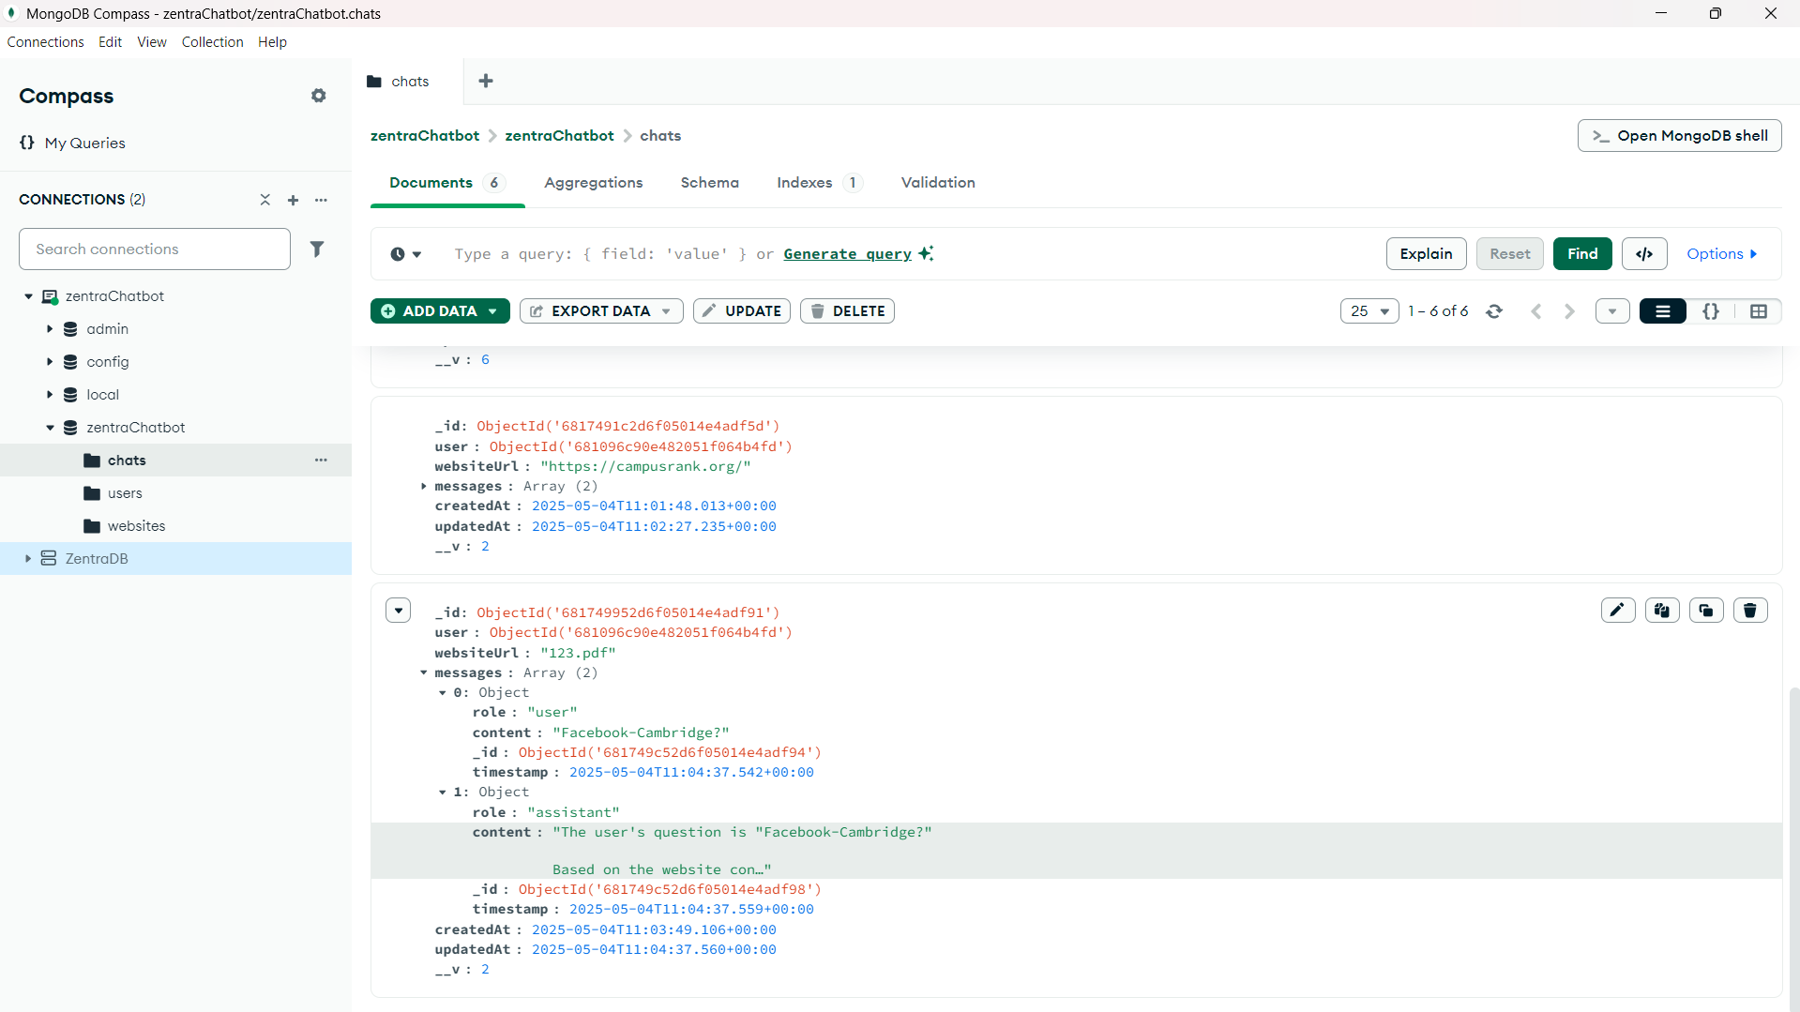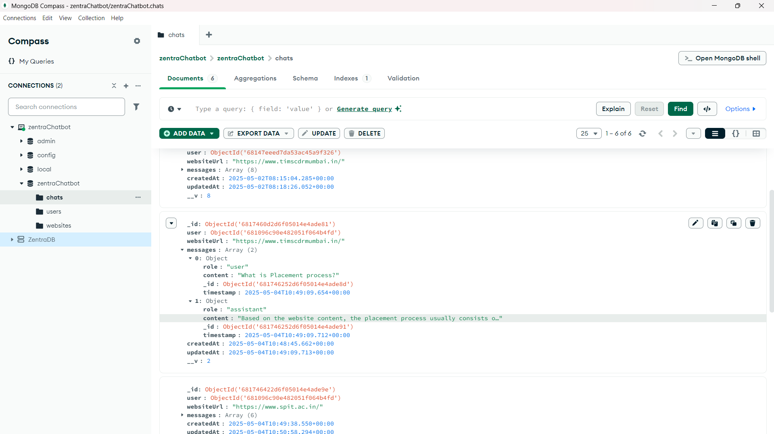

This Zentra Chatbot represents a sophisticated implementation of AI-powered website interaction, combining modern web technologies with advanced natural language processing to create a seamless user experience for extracting and discussing website content.